Security in Computing Practical 9
Configure IOS Intrusion Prevention System (IPS)
Practical 9
Aim:- Configure IOS Intrusion Prevention System (IPS) Using the CLI
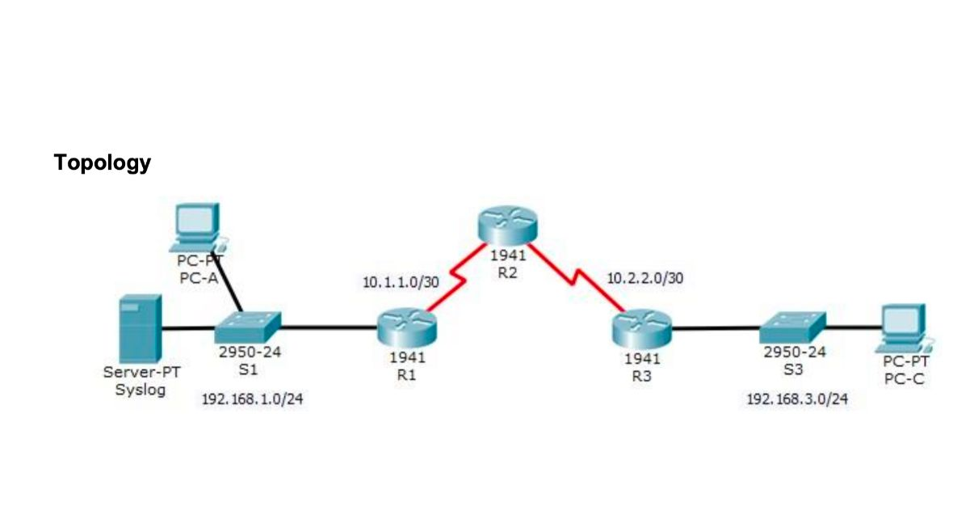

Basic Configuration (All Routers)
enable
conf t
enable secret enpa55
line console 0
password conpa55
login
exit
ip domain-name ccnasecurity.com
username admin secret adminpa55
line vty 0 4
login local
transport input ssh
exit
crypto key generate rsa
1024

OSPF Configuration
! R1
router ospf 1
network 192.168.1.0 0.0.0.255 area 0
network 10.1.1.0 0.0.0.3 area 0
! R2
router ospf 1
network 10.1.1.0 0.0.0.3 area 0
network 10.2.2.0 0.0.0.3 area 0
! R3
router ospf 1
network 10.2.2.0 0.0.0.3 area 0
network 192.168.3.0 0.0.0.255 area 0

IPS Configuration (R1)
license boot module c1900 technology-package securityk9
copy run start
reload
mkdir ipsdir
ip ips config location flash:ipsdir
ip ips name iosips
ip ips notify log
service timestamps log datetime msec
logging host 192.168.1.50
ip ips signature-category
category all
retired true
exit
category ios_ips basic
retired false
exit
exit
interface g0/0
ip ips iosips out

Modify IPS Signature
ip ips signature-definition
signature 2004 0
status
retired false
enabled true
exit
engine
event-action produce-alert
event-action deny-packet-inline
exit
exit
exit

Verification Steps
1. show ip ips all
2. Test:
Ping between PCs
One direction blocked after IPS
3. Check logs:
Syslog server → Services → SYSLOG
4. Expected:
Malicious traffic blocked
Normal traffic allowed
Practical 9: IOS IPS
On Router R1
- Verify IPS Config: Run show ip ips all to see the engine status and configured signatures.
On PC-C
- IPS Prevention: Run ping 192.168.1.2. It should be unsuccessful (Request timed out) because the signature 2004 was enabled to deny the packet.
On Syslog Server
- Alerts: Go to Services > SYSLOG to see the "Signature 2004" alerts generated by the ping attempt.

Practical 9: IOS IPS
- On R1:
  - show ip ips all: To verify the IPS engine is active and signatures are compiled.
  - show ip ips signatures: To check the status of specific signatures (e.g., signature 2004).
- On Syslog Server:
  - Check the Services > SYSLOG tab to see alerts for blocked "malicious" traffic.

Viva Questions
1. What is IPS?
Intrusion Prevention System detects and blocks attacks.
2. Difference IDS vs IPS?
IDS detects only, IPS detects and blocks.
3. What is signature?
Pattern used to detect attack.
4. Why logging?
To monitor attacks.
5. What is event-action?
Defines action taken when attack detected.

